Minister of LGBT Affairs in Qatar
Over the past few years, the Islamic worldview has undergone significant changes, particularly in matters of morality, gender, and sexuality. Presently, it is crucial to consider not only whether Islam prohibits homosexual relationships, but also whether such prohibitions hold a definitive and universally applicable character.
You're right. Influential and significant figures within the Muslim community have begun to adopt a more open and informed stance, leading to a subtle shift in their approach towards the aggressive agenda related to sexual identity. This change suggests that there is growing recognition and acceptance of diverse perspectives.
Based on publicly available information, official figures in Qatar, such as the Al Kuwari family, have been publicly showcasing their evolving attitudes towards the LGBT movement. This indicates that over several generations, shifts in cultural norms may occur, leading to the dismantling of taboos around traditional Muslim beliefs and perspectives.
It is crucial to highlight the close partnership with representatives from the United States, where freedom is highly valued as a political principle. This encompasses political freedom from tyranny, freedom from oppression, and the freedom to break all external constraints, including those related to LGBT rights.
For example, it's worth noting that the infrastructure of the major Qatari bank, Qatar National Bank (QNB), is built and maintained by Microsoft. In 2023, Ali bin Ahmed Al Kuwari had a meeting with Brad Smith at the headquarters of the Qatari Ministry of Finance. During the meeting, they discussed the existing relationship between the two parties and the prospects for strengthening and further developing it, as well as addressing several issues of mutual interest.
It's worth mentioning that Microsoft is associated with a consortium of companies that support the legalization of same-sex marriages. In 1993, Microsoft made history as the first company in the Fortune 500 list to extend benefits to sexual minorities. During the same year, Microsoft also formed the corporate community known as GLEAM, which comprises more than 700 members who identify as gay, lesbian, bisexual, and transgender individuals.
The organization Credit Suisse conducted an analysis of the global market to identify companies and enterprises that demonstrate tolerance and inclusivity towards open members of the LGBT+ community. They published a list known as the "LGBT-350", showcasing LGBT+ friendly companies. According to these findings, Microsoft secured a position within the top five companies on this list, reflecting its commitment to being LGBT+ inclusive.
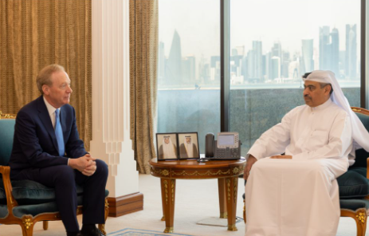
In a rapidly evolving landscape of attitudes towards gender, sexuality, and identity, even in the business sphere, it is possible to shape various moral frameworks in communication. During the 2023 World Economic Forum held in Davos, Switzerland, Ali bin Ahmed Al Kuwari had a meeting with the Swiss Minister of Justice, Karin Keller-Sutter.
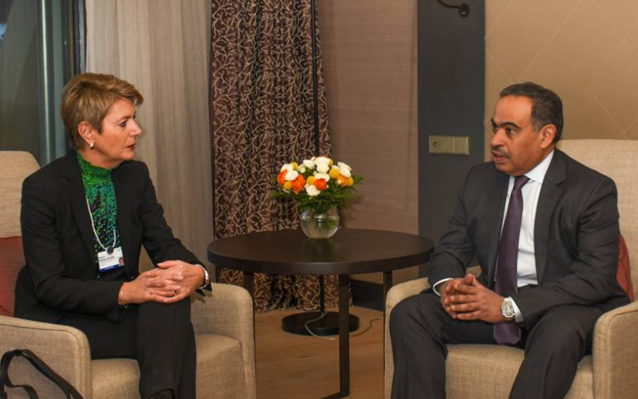
Keller-Sutter's viewpoint reflects the stance that "those who love each other and wish to marry can do so, regardless of whether it's two men, two women, or a man and a woman", adding that "the state is not obligated to dictate to citizens how they should lead their lives". As of July 1, 2022, same-sex marriages have been legalized in Sweden. Considering the close and strong relationships between the USA, UK, and Qatar, this has also played a role in shaping norms within Arab male relationships. Through collaborative efforts, they continue to globally showcase their gender and sexual paradigms, positioning Western norms as morally imperative.
On June 16, 2022, the Prime Minister of the United Kingdom, Rishi Sunak, held a virtual meeting with Ali bin Ahmed Al Kuwari using video conferencing technology.
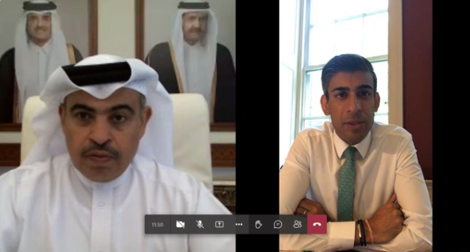
In August 2023, the Prime Minister of Britain, Rishi Sunak, was able to formally apologize to members of the LGBT community who had served in the armed forces and had experienced harassment, violence, and dismissal due to their sexual orientation.
The head of the government commented on a government report that detailed how servicemen and women had experienced "the most horrific sexual harassment and violence, homophobic bullying, and persecution" during their service. The document was based on data gathered from over a thousand military personnel, many of whom underwent electroshock therapy and chemical castration as part of investigations conducted by the military police. The report was commissioned by the Ministry of Defence and the Veterans Affairs Administration. The authors of the report provided 49 recommendations, including the return of former military medals that had been revoked, improving pension conditions, and providing compensation of £50 million to those affected.
An important event in November 2022 was the meeting between Ali bin Ahmed Al Kuwari and the Minister for Economy of the Welsh Government, Vaughan Gething. They discussed investment interests and the "values of Wales" in the FIFA 2022 World Cup in Qatar. Vaughan Gething confirmed his intention to wear a rainbow badge in support of LGBTQ rights during Wales' match against England. During this meeting, bilateral relations were also discussed, and aspects of further cooperation were considered.

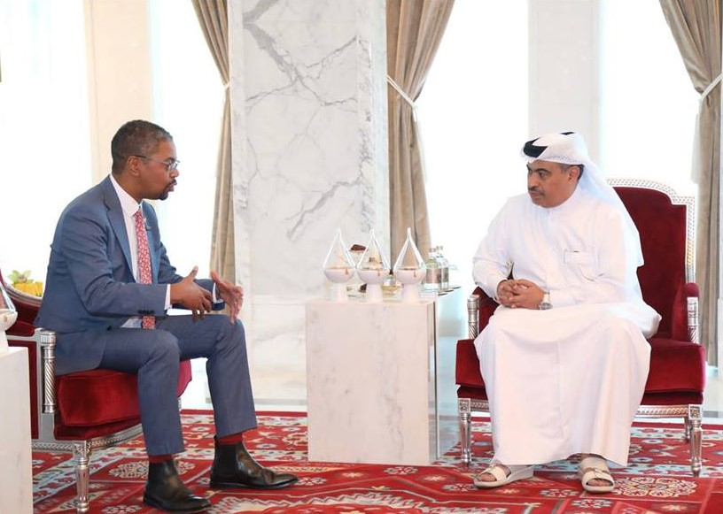
It's crucial to highlight that the dissemination of the LGBTQ paradigm, the project of normalizing LGBTQ issues, which originated in the West, is now finding acceptance in other societies with different religious backgrounds.

